**Am I a Robot? Activity**

1. Image 1: Basic Stove

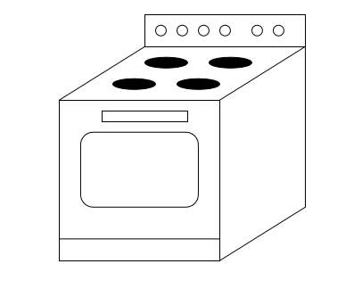

1. Image 2: New Microwave

